29.34: According to Eqn.29.14 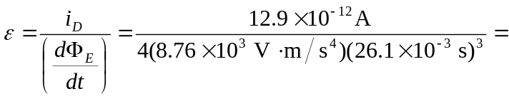 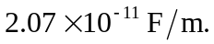Thus, the dielectric constant is 